MAGNA CODERS COMMUNITY APPLICATION

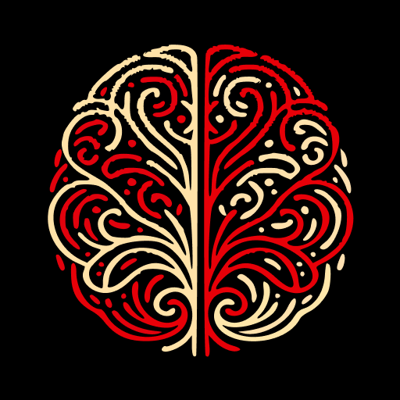

“Magna potestas magna cum responsabilitate venit”
With great power comes great responsibility

This document captures the foundation of Magna Coders. It defines the problem we aim to solve, the vision guiding us, and the principles shaping development. It serves as the north star for all subsequent documentation and decision-making

Table of Contents – Ideation & Conceptualization
Problem Statement………………………………………………………..5
Vision & Mission………………………………………….………………..5
Target Users / Personas……………………….………………………..5
Value Proposition……………………………….…………………………6
Success Metrics………………………………….…………………………6
High-Level Features (Conceptual).........................................6
Guiding Principles………………………………….…………………….6
Inspirations & Anti-Models……………………….…………………..7
Narrative Story – User Journey…………………….……………….7
Constraints / Non-Negotiables……………………….………………8

1. Problem Statement
Tech talent is abundant but fragmented. Developers, designers, and problem-solvers struggle not only to showcase their skills but also to find collaborators who can help transform ideas into real projects. Many individuals with promising ideas face dead ends because there is no simple way to invite others to join their initiatives. At the same time, businesses lack an accessible gateway to verified, collaborative talent, and local communities remain disconnected, with members unable to easily identify peers by location—whether in Nairobi, Mombasa, Kisumu, or beyond. Existing platforms and chat groups create noise without structure, leaving innovation stalled, talent underutilized, and ideas unrealized.

2. Vision / Mission
Vision: A living ecosystem where skills meet purpose to solve real-world problems with technology.
Mission: Organize skills into a visible, searchable network, facilitate peer collaboration, and connect businesses with coders for tech-driven solutions.

3. Target Users / Personas
- Developers & Designers: Want visibility, collaboration, and portfolio growth.
- Businesses & Organizations: Need skilled, vetted teams to solve challenges.
- Community Mentors/Advisors: Provide guidance and credibility to the ecosystem.

4. Value Proposition
Unlike Slack groups or LinkedIn, Magna Coders offers a purpose-built collaboration space where skills, projects, and opportunities converge. It is not just networking—it is an execution engine.

5. Success Metrics
- Number of collaborations/projects initiated.
- Retention of active contributors.
- Businesses successfully hiring or launching projects via the app.
- Growth of skill categories and diversity of expertise.
- Number of mini-project invitations posted and joined by members.
- Percentage of collaborations formed within local communities (e.g., Nairobi, Mombasa, Kisumu).

6. High-Level Features (Conceptual)
- Profiles & Portfolios (make skills visible).
- Skill Directory (structured, searchable talent).
- Collaboration Hub (form/join teams, manage projects).
- Opportunities Board (connect external problems to internal talent).
- Mini-Project Invitations (members can post small project ideas or challenges and invite others to join).
- Local Community Discovery (filter/search collaborators by city or region for geographically grounded projects).
- Community Recognition (leaderboards, highlights).

7. Guiding Principles
- Open-source ethos: community over individual ownership.
- Transparency in contributions and recognition.
- No exploitation of data for profit.
- Inclusive ecosystem—welcoming diverse skills, levels, and backgrounds.

8. Inspirations & Anti-Models
- Inspired by GitHub (collaboration), LinkedIn (professional visibility), and Kaggle (challenge-driven innovation).
- Avoids the pitfalls of most messaging apps that style noise and purely transactional job boards.

9. Narrative Story – User Journey
Before Magna Coders
Sarah, a young developer, scrolls through Slack groups and LinkedIn, hoping to find collaborators. Most conversations dissolve into noise—people pitching themselves but never building. When she applies for projects, businesses overlook her because she has no structured portfolio, only scattered GitHub links. She feels invisible, isolated, and underutilized.
After Magna Coders
Sarah creates her profile on Magna Coders. Her skills are visible in a searchable directory. A small NGO posts a challenge to build a lightweight donation-tracking tool. Sarah joins a team through the Collaboration Hub, contributes code directly via GitHub integration, and sees her work recognized on the community leaderboard. The NGO adopts the tool. Sarah gains both a portfolio project and real-world impact. Businesses can now find her by skill and availability. She is no longer invisible—she is part of a living ecosystem where skills meet purpose.

10. Constraints / Non-Negotiables
- Not a Freelance Marketplace
  - We are not like freelancing social platforms. Collaboration is purpose-driven, not transactional gig work.
- No Exploitation of Data
  - User data will never be sold or used for manipulative advertising.
- Quality over Vanity Metrics
  - Growth will be measured by meaningful collaborations and impact, not just sign-up numbers.
- Community First, Not Corporate First
  - Businesses are welcome as partners, but they do not dictate the culture or exploit talent.
- Avoiding Noise Overload
  - The platform will not devolve into unstructured chat or endless posting. Every interaction must serve skill visibility, collaboration, or problem-solving.
- Sustainability of Vision
  - Features that dilute open-source ethos or inclusivity will not be pursued, even if commercially tempting.

